**Big Data Hadoop & Spark (Data Flair)**

**Spark** Programming is nothing but a general-purpose & lightning fast cluster computing platform. In other words, it is an open source, wide range data processing engine. **Apache Spark** is general purpose cluster computing system. It provides high-level API in Java, Scala, Python, and R. Spark provide an optimized engine that supports general execution graph. It also has abundant high-level tools for structured data processing, machine learning, graph processing and streaming. The Spark can either run alone or on an existing cluster manager.

a. **Spark Core**: Spark Core is a central point of Spark. Basically, it provides an execution platform for all the Spark applications. Moreover, to support a wide array of applications, Spark Provides a generalized platform.

It is in charge of essential I/O functionalities.

Significant in programming and observing the role of the Spark cluster.

Task dispatching.

Fault recovery.

It overcomes the snag of MapReduce by using in-memory computation.

b. **Spark SQL**: On the top of Spark, Spark SQL enables users to run SQL/HQL queries. We can process structured as well as semi-structured data, by using Spark SQL. Moreover, it offers to run unmodified queries up to 100 times faster on existing deployments.

Cost based optimizer.

Mid query fault-tolerance: This is done by scaling thousands of nodes and multi-hour queries using the Spark engine.

Full compatibility with existing Hive data.

DataFrames and SQL provide a common way to access a variety of data sources. It includes Hive, Avro, Parquet, ORC, JSON, and JDBC.

Provision to carry structured data inside Spark programs, using either SQL or a familiar Data Frame API.

c. **Spark Streaming**: Basically, across live streaming, Spark Streaming enables a powerful interactive and data analytics application. Moreover, the live streams are converted into micro-batches those are executed on top of spark core. It is an add-on to core Spark API which allows scalable, high-throughput, fault-tolerant stream processing of live data streams. Spark can access data from sources like Kafka, Flume, Kinesis or TCP socket. It can operate using various algorithms. Finally, the data so received is given to file system, databases and live dashboards. Spark uses Micro-batching for real-time streaming. Micro-batching is a technique that allows a process or task to treat a stream as a sequence of small batches of data. Hence Spark Streaming, groups the live data into small batches. It then delivers it to the batch system for processing. It also provides fault tolerance characteristics.

a. **GATHERING**

The Spark Streaming provides two categories of built-in streaming sources:

Basic sources: These are the sources which are available in the StreamingContext API. Examples: file systems, and socket connections.

Advanced sources: These are the sources like Kafka, Flume, Kinesis, etc. are available through extra utility classes. Hence Spark access data from different sources like Kafka, Flume, Kinesis, or TCP sockets.

b. **PROCESSING**

The gathered data is processed using complex algorithms expressed with a high-level function. For example, map, reduce, join and window.

c. **DATA STORAGE**

The Processed data is pushed out to file systems, databases, and live dashboards.

Spark Streaming also provides high-level abstraction. It is known as discretized stream or DStream.

DStream in Spark signifies continuous stream of data. We can form DStream in two ways either from sources such as Kafka, Flume, and Kinesis or by high-level operations on other DStreams. Thus, DStream is internally a sequence of RDDs.

d. **Spark MLlib**: Machine learning library delivers both efficiencies as well as the high-quality algorithms. Moreover, it is the hottest choice for a data scientist. Since it is capable of in-memory data processing, that improves the performance of iterative algorithm drastically.

MLlib is switching to DataFrame-based API is that it is more user-friendly than RDD. Some of the benefits of using DataFrames are it includes Spark Data sources, SQL DataFrame queries Tungsten and Catalyst optimizations, and uniform APIs across languages. MLlib also uses the linear algebra package Breeze. Breeze is a collection of libraries for numerical computing and machine learning.

e. **Spark GraphX**: Basically, Spark GraphX is the graph computation engine built on top of Apache Spark that enables to process graph data at scale. Clustering, classification, traversal, searching, and pathfinding is also possible in graphs. Furthermore, GraphX extends Spark RDD by bringing in light a new Graph abstraction: a directed multigraph with properties attached to each vertex and edge.

GraphX also optimizes the way in which we can represent vertex and edges when they are primitive data types. To support graph computation it supports fundamental operators (e.g., subgraph, join Vertices, and aggregate Messages) as well as an optimized variant of the Pregel API

f. **SparkR**: Basically, to use Apache Spark from R. It is R package that gives light-weight frontend. Moreover, it allows data scientists to analyze large datasets. Also allows running jobs interactively on them from the R shell. Although, the main idea behind SparkR was to explore different techniques to integrate the usability of R with the scalability of Spark.

Data Sources API: By tying into Spark SQL’s data sources API SparkR can read in data from a variety of sources. For example, Hive tables, JSON files, Parquet files etc.

Data Frame Optimizations: SparkR DataFrames also inherit all the optimizations made to the computation engine in terms of code generation, memory management.

Scalability to many cores and machines: Operations that executes on SparkR DataFrames get distributed across all the cores and machines available in the Spark cluster. As a result, SparkR DataFrames can run on terabytes of data and clusters with thousands of machines.

**Resilient Distributed Dataset – RDD**: Parallelized collections, External datasets, Existing RDDs. In-memory computation, Lazy Evaluation, Fault Tolerance, Immutability, Persistence, Partitioning, Parallel, Location-Stickiness, Coarse-grained Operation, Typed, No limitation

**Limitation of Spark RDD:**

**Handling structured data**: Unlike Dataframe and datasets, RDDs don’t infer the schema of the ingested data and requires the user to specify it.

**Performance limitation**: Being in-memory JVM objects, RDDs involve the overhead of Garbage Collection and Java Serialization which are expensive when data grows.

**Storage limitation**: RDDs degrade when there is not enough memory to store them. One can also store that partition of RDD on disk which does not fit in RAM. As a result, it will provide similar performance to current data-parallel systems.

**No input optimization engine**: There is no provision in RDD for automatic optimization. It cannot make use of Spark advance optimizers like catalyst optimizer and Tungsten execution engine. We can optimize each RDD manually. This limitation is overcome in Dataset and DataFrame, both make use of Catalyst to generate optimized logical and physical query plan. We can use same code optimizer for R, Java, Scala, or Python DataFrame/Dataset APIs. It provides space and speed efficiency.

**Runtime type safety:** There is no Static typing and run-time type safety in RDD. It does not allow us to check error at the runtime. Dataset provides compile-time type safety to build complex data workflows. Compile-time type safety means if you try to add any other type of element to this list, it will give you compile time error. It helps detect errors at compile time and makes your code safe.

**Degrade when not enough memory:** The RDD degrades when there is not enough memory to store RDD in-memory or on disk. There comes storage issue when there is a lack of memory to store RDD. The partitions that overflow from RAM can be stored on disk and will provide the same level of performance. By increasing the size of RAM and disk it is possible to overcome this issue.

**Performance limitation & Overhead of serialization & garbage collection:** Since the RDD are in-memory JVM object, it involves the overhead of Garbage Collection and Java serialization this is expensive when the data grows. Since the cost of garbage collection is proportional to the number of Java objects. Using data structures with fewer objects will lower the cost. Or we can persist the object in serialized form.

**Handling structured data:** RDD does not provide schema view of data. It has no provision for handling structured data.

Dataset and DataFrame provide the Schema view of data. It is a distributed collection of data organized into named columns.

**RDD Persistence and Caching Mechanism in Apache Spark**: Spark RDD persistence is an optimization technique in which saves the result of RDD evaluation. Using this we save the intermediate result so that we can use it further if required. It reduces the computation overhead. We can make persisted RDD through cache() and persist() methods. When we use the cache() method we can store all the RDD in-memory. We can persist the RDD in memory and use it efficiently across parallel operations. The difference between cache() and persist() is that using cache() the default storage level is MEMORY_ONLY while using persist() we can use various storage levels (described below). It is a key tool for an interactive algorithm. Because, when we persist RDD each node stores any partition of it that it computes in memory and makes it reusable for future use. This process speeds up the further computation ten times.

**Features of Apache Spark**: Swift Processing, Dynamic in Nature, In-Memory Computation in Spark, Reusability, Spark Fault Tolerance, Real-Time Stream Processing, Lazy Evaluation in Spark, Support Multiple Languages, Support for Sophisticated Analysis, Integrated with Hadoop, Spark GraphX, Cost Efficient

**Limitations of Apache Spark Programming**: No Support for Real-time Processing, Problem with Small File, No File Management System, Expensive, Less number of Algorithms, Manual Optimization, Iterative Processing, Latency, Window Criteria

The most important step of any Spark driver application is to generate SparkContext. It allows your Spark Application to access Spark Cluster with the help of Resource Manager (YARN/Mesos). To create SparkContext, first SparkConf should be made. The SparkConf has a configuration parameter that our Spark driver application will pass to SparkContext.

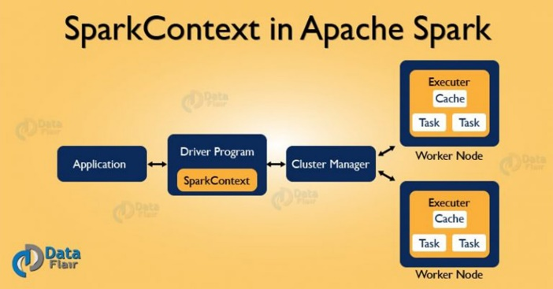

**SpkEnv** – It is a runtime environment with Spark’s public services. It interacts with each other to establish a distributed computing platform for Spark Application. A SparkEnv object that holds the required runtime services for running Spark application with the different environment for the driver and executor represents the Spark runtime environment.

**SparkConf** – The Spark Properties handles maximum applications settings and are configured separately for each application. We can also easily set these properties on a SparkConf. Some common properties like master URL and application name, as well as an arbitrary key-value pair, configured through the set() method.

**Deployment environment (as master URL)** – Spark deployment environment are of two types namely local and clustered. Local mode is non-distributed single-JVM deployment mode. All the execution components – driver, executor, LocalSchedulerBackend, and master are present in same single JVM. Hence, the only mode where drivers are useful for execution is the local mode. For testing, debugging or demonstration purpose, the local mode is suitable because it requires no earlier setup to launch spark application. While in clustered mode, the Spark runs in distributive mode

**accessing services** like TaskScheduler, LiveListenBus, BlockManager, SchedulerBackend, ShuffelManager and the optional ContextCleaner

**cancleStage** simply requests DAGScheduler to drop a Spark stage

**getPersistentRDDs** gives the collection of RDDs that have marked themselves as persistent via cache

A **stage** is nothing but a step in a physical execution plan. Moreover, It is a physical unit of the execution plan. Stage is a set of parallel tasks i.e. one task per partition. Basically, each job which gets divided into smaller sets of tasks is a stage.

**ShuffleMapStage** is considered as an intermediate Spark stage in the physical execution of DAG. Basically, it produces data for another stage(s). Also, for a shuffle writes map output files.

**ResultStage**: By running a function on a spark RDD Stage that executes a Spark action in a user program is a ResultStage. Moreover, it is considered as a final stage in spark. Although, ResultStage implies as a final stage in a job that applies a function on one or many partitions of the target RDD in Spark. Also, helps for computation of the result of an action.

**Executors** in Spark are worker nodes. Those help to process in charge of running individual tasks in a given Spark job. Moreover, we launch them at the start of a Spark application. Then it typically runs for the entire lifetime of an application. As soon as they have run the task, sends results to the driver. Executors also provide in-memory storage for Spark RDDs that are cached by user programs through Block Manager.

**persist** method to indicate which RDDs they want to reuse in future operations. Spark keeps persistent RDDs in memory by default, but it can **spill them to disk if there is not enough RAM**. Users can also request other persistence strategies, such as storing the RDD only on disk or replicating it across machines, through flags to persist.

**Features of Spark RDD**: In-memory Computation, Lazy Evaluations , Fault Tolerance, Immutability, Partitioning, Persistence, Coarse-grained Operations, Location-Stickiness

**Narrow Transformations**: It is the result of map, filter and such that the data is from a single partition only, i.e. it is self-sufficient. An output RDD has partitions with records that originate from a single partition in the parent RDD. Only a limited subset of partitions used to calculate the result.

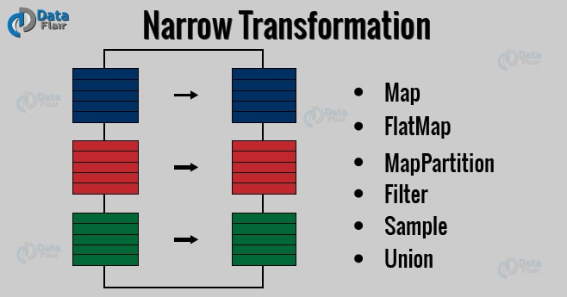 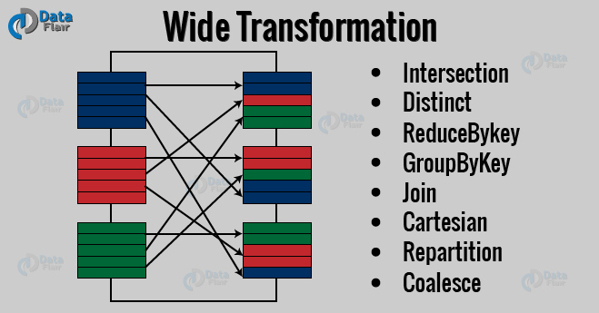

**Wide Transformations**: It is the result of groupByKey() and reduceByKey() like functions. The data required to compute the records in a single partition may live in many partitions of the parent RDD. Wide transformations are also known as shuffle transformations because they may or may not depend on a shuffle.

**Advantages of In-memory Processing**

* When we need a data to analyze it is already available on the go or we can retrieve it easily.
* It is good for real-time risk management and fraud detection.
* The data becomes highly accessible.
* The computation speed of the system increases.
* Improves complex event processing.
* Cached a large amount of data.
* It is economic, as the cost of RAM has fallen over a period of time.

**Advantages of Lazy Evaluation in Spark Transformation:** Increases Manageability, Saves Computation and increases Speed, Reduces Complexities, Optimization

**Fault tolerance in Apache Spark**

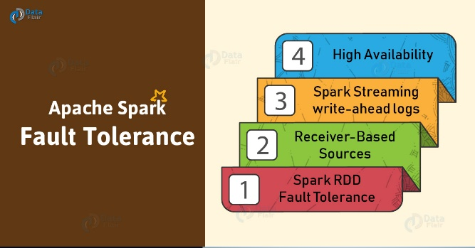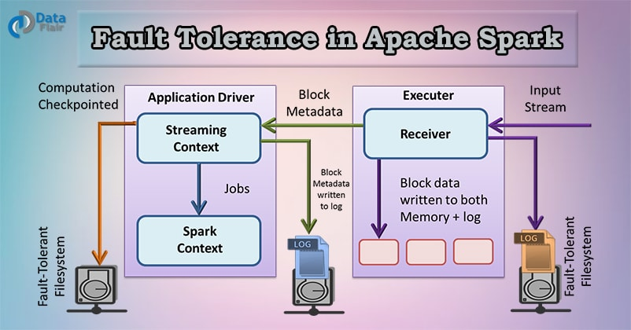

* Since Apache Spark RDD is an immutable dataset, each Spark RDD remembers the lineage of the deterministic operation that was used on fault-tolerant input dataset to create it.
* If due to a worker node failure any partition of an RDD is lost, then that partition can be re-computed from the original fault-tolerant dataset using the lineage of operations.
* Assuming that all of the RDD transformations are deterministic, the data in the final transformed RDD will always be the same irrespective of failures in the Spark cluster.

This results in two types of data that needs to recover in the event of failure:

**Data received and replicated** – In this, the data gets replicated on one of the other nodes thus the data can be retrieved when a failure.

**Data received but buffered for replication –** The data is not replicated thus the only way to recover fault is by retrieving it again from the source.

**Failure of worker node –** The node which runs the application code on the Spark cluster is Spark worker node. These are the slave nodes. Any of the worker nodes running executor can fail, thus resulting in loss of in-memory If any receivers were running on failed nodes, then their buffer data will be lost.

**Failure of driver node –** If there is a failure of the driver node that is running the Spark Streaming application, then SparkContent losses and all executors lose their in-memory data.

**Apache Mesos helps** in making the Spark master fault tolerant by maintaining the backup masters. It is open source software residing between the application layer and the operating system. It makes easier to deploy and manage applications in large-scale clustered environment. Executors are relaunched if they fail. Post failure, executors are relaunched automatically and spark streaming does parallel recovery by recomputing Spark RDD’s on input data. Receivers are restarted by the workers when they fail.

**Fault Tolerance with Receiver-based sources**

* **Reliable receiver –** Once we ensure that the received data replicates, the reliable sources are acknowledged. If the receiver fails, the source will not receive acknowledgment for the buffered data. So, the next time restarts the receiver, the source will resend the data. Hence, no data will lose due to failure.
* **Unreliable Receiver –** Due to the worker or driver failure, the data can loss sincethe receiver does not send an acknowledgment.

**If the worker node fails**, and the receiver is reliable there will be no data loss. But in the case of unreliable receiver data loss will occur. With the unreliable receiver, data received but not replicated can be lost.

**Spark Streaming write ahead logs**

If the driver node fails, all the data that was received and replicated in memory will be lost. This will affect the result of the stateful transformation. To avoid the loss of data, Spark 1.2 introduced write ahead logs, which save received data to fault-tolerant storage. All the data received is written to write ahead logs before it can be processed to Spark Streaming.

Write ahead logs are used in database and file system. It ensure the durability of any data operations. It works in the way that first the intention of the operation is written down in the durable log. After this, the operation is applied to the data. This is done because if the system fails in the middle of applying the operation, the lost data can be recovered. It is done by reading the log and reapplying the data it has intended to do.

**High Availability**

We can say any system highly available if its downtime is tolerable. This time depends on how critical the application is. Zero down time is an imaginary term for any system. Consider any machine has an uptime of 97.7%, so its probability to go down will be 0.023. If we have similar two machines, then the probability of both of them going down will be (0.023*0.023). in most high availability environment we have three machines in use, in that case, the probability of going down is (0.023*0.023*0.023) i.e. 0.000012167, which guarantees an uptime of system to be 99.9987833% which is highly acceptable uptime guarantee.

**Directed Acyclic Graph DAG in Apache Spark**

DAG in Apache Spark is a set of Vertices and Edges, where vertices represent the RDDs and the edges represent the Operation to be applied on RDD. In Spark DAG, every edge directs from earlier to later in the sequence. On the calling of Action, the created DAG submits to DAG Scheduler which further splits the graph into the stages of the task.

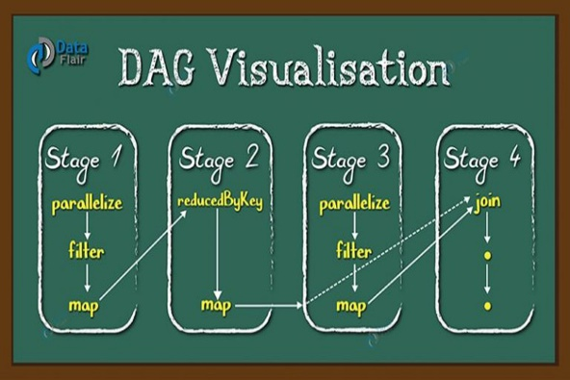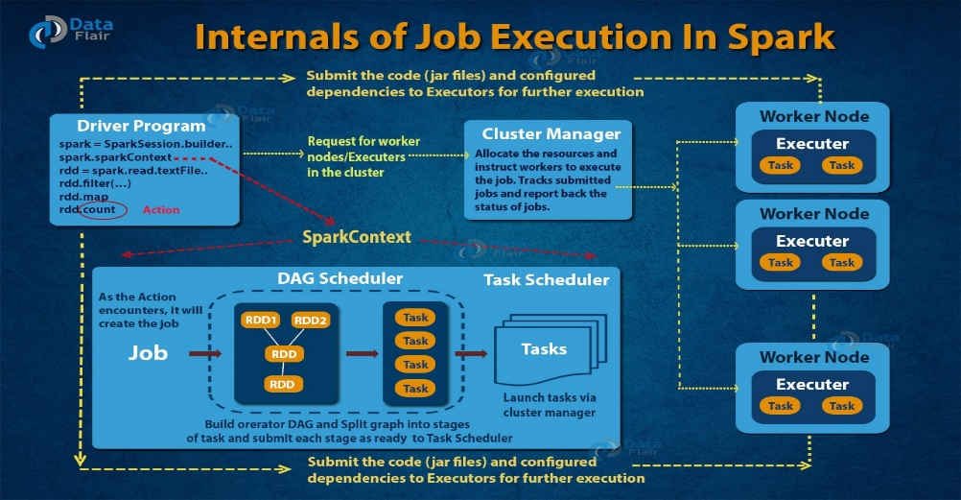

**How DAG works in Spark?**

* The interpreter is the first layer, using a Scala interpreter, Spark interprets the code with some modifications.
* Spark creates an operator graph when you enter your code in Spark console.
* When we call an Action on Spark RDD at a high level, Spark submits the operator graph to the DAG Scheduler.
* Divide the operators into stages of the task in the DAG Scheduler. A stage contains task based on the partition of the input data. The DAG scheduler pipelines operators together. For example, map operators schedule in a single stage.
* The stages pass on to the Task Scheduler. It launches task through cluster manager. The dependencies of stages are unknown to the task scheduler.
* The Workers execute the task on the slave.

**DAG Advantages:**

* The lost RDD can recover using the Directed Acyclic Graph.
* Map Reduce has just two queries the map, and reduce but in DAG we have multiple levels. So to execute SQL query, DAG is more flexible.
* DAG helps to achieve fault tolerance. Thus we can recover the lost data.
* It can do a better global optimization than a system like Hadoop MapReduce.

**Apache Spark Cluster Managers – YARN, Mesos & Standalone**

**Spark Standalone Cluster:** It has masters and number of workers with configured amount of memory and CPU cores. In Spark standalone cluster mode, Spark allocates resources based on the core. By default, an application will grab all the cores in the cluster.

In standalone cluster manager, Zookeeper quorum recovers the master using standby master. Using the file system, we can achieve the manual recovery of the master. Spark supports authentication with the help of shared secret with entire cluster manager. The user configures each node with a shared secret. For communication protocols, Data encrypts using SSL. But for block transfer, it makes use of data SASL encryption.

To check the application, each Apache Spark application has a Web User Interface. The Web UI provides information of executors, storage usage, running task in the application. In this cluster manager, we have Web UI to view cluster and job statistics. It also has detailed log output for each job. If an application has logged event for its lifetime, Spark Web UI will reconstruct the application’s UI after the application exits.

**Apache Mesos**

Apache Mesos is the reverse of virtualization. This is because in virtualization one physical resource divides into many virtual resources. While in Mesos many physical resources are club into a single virtual resource

**Mesos Master** is an instance of the cluster. A cluster has many Mesos masters that provide fault tolerance. Here one instance is the leading master. **Mesos Slave** is Mesos instance that offers resources to the cluster. Mesos Master assigns the task to the slave. **Mesos Framework** allows applications to request the resources from the cluster. Thus, the application can perform the task. Some other Frameworks by Mesos are Chronos, Marathon, Aurora, Hadoop, Spark, Jenkins etc.

**Mesos authentication includes:**

* The slave’s registration with the master.
* Frameworks (that is, applications) submission to the cluster.
* Operators using endpoints such as HTTP endpoints.

**Hadoop YARN**

**YARN** data computation framework is a combination of the ResourceManager, the NodeManager. It can run on Linux and Windows.

The **Yarn Resource Manager** manages resources among all the applications in the system. The Resource Manager has scheduler and Application Manager. The Scheduler allocates resource to the various running application. It is pure Scheduler, performs monitoring or tracking of status for the application. The Application Manager manages applications across all the nodes.

**Yarn Node Manager** contains Application Master and container. A container is a place where a unit of work happens. Each task of MapReduce runs in one container. The per-application Application Master is a framework specific library. It aims to negotiate resources from the Resource Manager. It continues with Node Manager(s) to execute and watch the tasks.

The application or job requires one or more containers. Node Manager handles monitoring containers, resource usage (CPU, memory, disk, and network). It reports this to the Resource Manager. YARN provides security for authentication, service level authorization. It also provides authentication for Web consoles and data confidentiality. Hadoop authentication uses Kerberos to verify that each user and service has authentication.

|  |  |  |  |
| --- | --- | --- | --- |
|  | **Spark Standalone** | **Mesos** | **Yarn** |
| **High Availability** | with ZooKeeper Quorum it supports an automatic recovery of the master. One can achieve manual recovery using the file system. The cluster tolerates the worker failure despite the recovery of the Master is enabling or not | using Apache ZooKeeper it supports an automatic recovery of the master. In the case of failover, tasks which are currently executing, do not stop their execution. | using a command line utility it supports manual recovery. And use Zookeeper-based ActiveStandbyElector embedded in the ResourceManager for automatic recovery. Thus, there is no need to run a separate ZooKeeper Failover Controller. |
| **Security** | Spark supports authentication via a shared secret with all the cluster managers. The standalone manager requires the user to configure each of the nodes with the shared secret. Data can be encrypted using SSL for the communication protocols. SASL encryption is supported for block transfers of data. Other options are also available for encrypting data. Access to Spark applications in the Web UI can be controlled via access control lists. | For any entity interacting with the cluster Mesos provides authentication. This includes the slaves registering with the master, frameworks submitted to the cluster, and operators using endpoints such as HTTP endpoints. These entities can be enabling to use authentication or not. Custom module can replace Mesos’ default authentication module, Cyrus SASL.  To allow access to services in Mesos Access, it makes use of control lists. By default, communication between the modules in Mesos is unencrypted. SSL/TLS can be enabled to encrypt communication. Mesos WebUI supports HTTPS. | It contains security for authentication, service level authorization, authentication for Web consoles and data confidentiality. Using Service level authorization it ensures that client using Hadoop services has authority. Using access control lists Hadoop services can be controlled. Additionally, using SSL data and communication between clients and services is encrypted. The data transferred between the Web console and clients with HTTPS. |
| **Monitoring** | To view cluster and job statistics it has a Web UI. It also has detailed log output for each job. the Spark Web UI will reconstruct the application’s UI after the application exists if an application has logged events for its lifetime. | It supports per container network monitoring and isolation. It provides many metrics for master and slave nodes accessible with URL. These metrics include percentage and number of allocated CPU’s, memory usage etc. | it has a Web UI for the ResourceManager and the NodeManager. The ResourceManager UI provides metrics for the cluster. And the NodeManager provides information for each node, the applications and containers running on the node. |

**How Apache Spark Works – Run-time Spark Architecture**

**Apache Spark** is an open source, general-purpose distributed computing engine used for processing and analyzing a large amount of data. Just like Hadoop MapReduce, it also works with the system to distribute data across the cluster and process the data in parallel. Spark uses master/slave architecture i.e. one central coordinator and many distributed workers. Here, the central coordinator is called the driver.

The driver runs in its own Java process. These drivers communicate with a potentially large number of distributed workers called executors. Each executor is a separate java process. A Spark Application is a combination of driver and its own executors. With the help of cluster manager, a Spark Application is launched on a set of machines. Standalone Cluster Manager is the default built in cluster manager of Spark. Apart from its built-in cluster manager, Spark also works with some open source cluster manager like Hadoop Yarn, Apache Mesos etc.

* **Apache SparkContext**

SparkContext is the heart of Spark Application. It establishes a connection to the Spark Execution environment. It is used to create Spark RDDs, accumulators, and broadcast variables, access Spark services and run jobs. SparkContext is a client of Spark execution environment and acts as the master of Spark application. The main works of Spark Context are:

* + Getting the current status of spark application
  + Canceling the job
  + Canceling the Stage
  + Running job synchronously
  + Running job asynchronously
  + Accessing persistent RDD
  + Unpersisting RDD
  + Programmable dynamic allocation
* **Apache Spark Shell**

Spark Shell is a Spark Application written in Scala. It offers command line environment with auto-completion. It helps us to get familiar with the features of Spark, which help in developing our own Standalone Spark Application. Thus, this tool helps in exploring Spark and is also the reason why Spark is so helpful in processing data set of all size.

* **Spark Application**

The Spark application is a self-contained computation that runs user-supplied code to compute a result. A Spark application can have processes running on its behalf even when it’s not running a job.

* **Task**

A task is a unit of work that sends to the executor. Each stage has some task, one task per partition. The Same task is done over different partitions of RDD.

* **Job**

The job is parallel computation consisting of multiple tasks that get spawned in response to actions in Apache Spark.

* **Stage**

Each job divides into smaller sets of tasks called stages that depend on each other. Stages are classified as computational boundaries. All computation cannot be done in a single stage. It achieves over many stages.

**Components of Spark Run-time Architecture**

* **Apache Spark Driver**

The main() method of the program runs in the driver. The driver is the process that runs the user code that creates RDDs, and performs transformation and action, and also creates SparkContext. When the Spark Shell is launched, this signifies that we have created a driver program. On the termination of the driver, the application is finished.

The driver program splits the Spark application into the task and schedules them to run on the executor. The task scheduler resides in the driver and distributes task among workers. The two main key roles of drivers are:

* + Converting user program into the task.
  + Scheduling task on the executor.

The structure of Spark program at a higher level is: RDDs consist of some input data, derive new RDD from existing using various transformations, and then after it performs an action to compute data. In Spark Program, the DAG (directed acyclic graph) of operations create implicitly. And when the driver runs, it converts that Spark DAG into a physical execution plan.

* **Apache Spark Cluster Manager**

Spark relies on cluster manager to launch executors and in some cases, even the drivers launch through it. It is a pluggable component in Spark. On the cluster manager, jobs and action within a spark application scheduled by Spark Scheduler in a FIFO fashion. Alternatively, the scheduling can also be done in Round Robin fashion. The resources used by a Spark application can dynamically adjust based on the workload. Thus, the application can free unused resources and request them again when there is a demand. This is available on all coarse-grained cluster managers, i.e. standalone mode, YARN mode, and Mesos coarse-grained mode.

* **Apache Spark Executors**

The individual task in the given Spark job runs in the Spark executors. Executors launch once in the beginning of Spark Application and then they run for the entire lifetime of an application. Even if the Spark executor fails, the Spark application can continue with ease. There are two main roles of the executors:

* + Runs the task that makes up the application and returns the result to the driver.
  + Provide in-memory storage for RDDs that are cached by the user.
* **spark-submit**

Spark comes with the facility of a single script that can use to submit a program, called as spark-submit. It launches the application on the cluster. There are various options through which spark-submit can connect to different cluster manager and control how many resources our application gets. For some cluster managers, spark-submit can run the driver within the cluster (e.g., on a YARN worker node), while for others, it can run only on your local machine.

* + Using spark-submit, the user submits an application.
  + In spark-submit, we invoke the main() method that the user specifies. It also launches the driver program.
  + The driver program asks for the resources to the cluster manager that we need to launch executors.
  + The cluster manager launches executors on behalf of the driver program.
  + The driver process runs with the help of user application. Based on the actions and transformation on RDDs, the driver sends work to executors in the form of tasks.
  + The executors process the task and the result sends back to the driver through the cluster manager.

**spark-submit** --class my.main.Class \

--master yarn \

--deploy-mode cluster \

--jars my-other-jar.jar,my-other-other-jar.jar \

my-main-jar.jar \

app_arg1 app_arg2

**yarn logs** -applicationId <app ID>

logs keep locally on each machine under yarn_app_logs_dir, which generally configures to /tmp/logs or $HADOOP_HOME/logs/userlogs depending on the Hadoop version and installation.

If we want to view log from a container, we must first go to the host that contains it and look in the directory. Further, the sub-directory maintains log files by application ID and container ID.

**Spark Performance Tuning**

**Data Serialization in Spark**

t is the process of converting the in-memory object to another format that can be used to store in a file or send over the network. It plays a distinctive role in the performance of any distributed application. The computation gets slower due to formats that are slow to serialize or consume a large number of files. Apache Spark gives two serialization libraries:

* Java serialization
* Kryo serialization

**Java serialization** – Objects are serialized in Spark using an ObjectOutputStream framework, and can run with any class that implements java.io.Serializable. The performance of serialization can be controlled by extending java.io.Externalizable. It is flexible but slow and leads to large serialized formats for many classes.

**Kryo serialization** – To serialize objects, Spark can use the Kryo library (Version 2). Although it is more compact than Java serialization, it does not support all Serializable types. For better performance, we need to register the classes in advance. We can switch to Karyo by initializing our job with SparkConf and calling-

conf.set(“spark.serializer”, “org.apache.spark.serializer.KyroSerializer”)

We use the registerKryoClasses method, to register our own class with Kryo. In case our objects are large we need to increase spark.kryoserializer.buffer config. The value should be large so that it can hold the largest object we want to serialize.

**Memory Tuning in Spark**

* Amount of memory used by objects (the entire dataset should fit in-memory)
* The cost of accessing those objects
* Overhead of garbage collection.

The Java objects can be accessed but consume 2-5x more space than the raw data inside their field. The reasons for such behavior are:

* Every distinct Java object has an “object header”. The size of this header is 16 bytes. Sometimes the object has little data in it, thus in such cases, it can be bigger than the data.
* There are about 40 bytes of overhead over the raw string data in Java String. It stores each character as two bytes because of String’s internal usage of UTF-16 encoding. If there are 10 characters String, it can easily consume 60 bytes.
* Common collection classes like HashMap and LinkedList make use of linked data structure, there we have “wrapper” object for every entry. This object has both header and pointer (8 bytes each) to the next object in the list.
* Collections of primitive types often store them as “boxed objects”. For example, java.lang.Integer.

**a. Spark Data Structure Tuning**

By avoiding the Java features that add overhead we can reduce the memory consumption. There are several ways to achieve this:

* Avoid the nested structure with lots of small objects and pointers.
* Instead of using strings for keys, use numeric IDs or enumerated objects.
* If the RAM size is less than 32 GB, set JVM flag to –xx:+UseCompressedOops to make a pointer to four bytes instead of eight.

**b. Spark Garbage Collection Tuning**

**JVM garbage collection** is problematic with large churn RDD stored by the program. To make room for new objects, Java removes the older one; it traces all the old objects and finds the unused one. But the key point is that cost of garbage collection in Spark is proportional to a number of Java objects. Thus, it is better to use a data structure in Spark with lesser objects. One more way to achieve this is to persist objects in serialized form. As a result, there will be only one object per RDD partition.

**Memory Types: execution and storage** The memory which is for computing in shuffles, Joins, aggregation is Execution memory. While the one for caching and propagating internal data in the cluster is storage memory. Both execution and storage share a unified region M. When the execution memory is not in use, the storage can use all the memory. The same case lies true for Storage memory. Execution can drive out the storage if necessary. This is done only until storage memory usage falls under certain threshold R

**Spark Garbage Collection Tuning**

In garbage collection, tuning in Apache Spark, the first step is to gather statistics on how frequently garbage collection occurs. It also gathers the amount of time spent in garbage collection. Thus, can be achieved by adding -verbose:gc -XX:+PrintGCDetails -XX:+PrintGCTimeStamps to Java option. The next time when Spark job run, a message will display in workers log whenever garbage collection occurs. These logs will be in worker node, not on drivers program.

Java heap space divides into two regions Young and Old. The young generation holds short-lived objects while Old generation holds objects with longer life. The garbage collection tuning aims at, long-lived RDDs in the old generation. It also aims at the size of a young generation which is enough to store short-lived objects. With this, we can avoid full garbage collection to gather temporary object created during task execution. Some steps that may help to achieve this are:

* If full garbage collection is invoked several times before a task is complete this ensures that there is not enough memory to execute the task.
* In garbage collection statistics, if OldGen is near to full we can reduce the amount of memory used for caching. This can be achieved by lowering spark.memory.fraction. the better choice is to cache fewer objects than to slow down task execution. Or we can decrease the size of young generation i.e., lowering –Xmn.

**Other consideration for Spark Performance Tuning**

**a. Level of Parallelism**

To use the full cluster the level of parallelism of each program should be high enough. According to the size of the file, Spark sets the number of “Map” task to run on each file. The level of parallelism can be passed as a second argument. We can set the config property spark.default.parallelism to change the default.

**b. Memory Usage of Reduce Task in Spark**

Although RDDs fit in our memory many times we come across a problem of OutOfMemoryError. This is because the working set of our task say groupByKey is too large. We can fix this by increasing the level of parallelism so that each task’s input set is small. We can increase the number of cores in our cluster because Spark reuses one executor JVM across many tasks and has low task launching cost.

**c. Broadcasting Large Variables**

The size of each serialized task reduces by using broadcast functionality in SparkContext. If a task uses a large object from driver program inside of them, turn it into the broadcast variable. Generally, it considers the tasks that are about 20 Kb for optimization.

**d. Data Locality in Apache Spark**

Data locality plays an important role in the performance of Spark Jobs. The case in which the data and code that operates on that data are together, the computation is faster. But if the two are separate, then either the code should be moved to data or vice versa. It is faster to move serialized code from place to place then the chunk of data because the size of the code is smaller than the data.

Based on data current location there are various levels of locality. The order from closest to farthest is:

* The best possible locality is that the PROCESS_LOCAL resides in same JVM as the running code.
* NODE_LOCAL resides on the same node in this. It is because the data travel between processes is quite slower than PROCESS_LOCAL.
* There is no locality preference in NO_PREF data is accessible from anywhere.
* RACK_LOCAL data is on the same rack of the server. Since the data is on the same rack but on the different server, so it sends the data in the network, through a single switch.
* ANY data resides somewhere else in the network and not in the same rack.

**Limitations of Apache Spark**: No Support for Real-time Processing, Problem with Small File, No File Management System, Expensive, Less number of Algorithms, Manual Optimization, Iterative Processing, Latency, Window Criteria, Back Pressure Handling

**Apache Spark SQL**

Apache Spark SQL integrates relational processing with Sparks functional programming. It is Spark module for structured data processing. Spark SQL blurs the line between RDD and relational table. It also offers much tighter integration between relational and procedural processing, through declarative DataFrame APIs which integrates with Spark code. It thus provides higher optimization. DataFrame API and Datasets API are the ways to interact with Spark SQL. As a result, with Spark SQL, Apache Spark is accessible to more users and improves optimization for current ones.

It allows developers to import relational data from Hive tables and parquet files, run SQL queries over imported data and existing RDDs and easily write RDDs out to Hive tables or Parquet files.

**Apache Spark SQL Interfaces**

**i. DataFrame:** Spark DataFrames evaluates lazily like RDD Transformations in Apache Spark. A DataFrame is equivalent to the relational table in Spark SQL. A DataFrame stores the data into tables. DataFrame is similar/identical to a table in a relational database but with richer optimization. It is a data abstraction and domain-specific language (DSL) applicable on the structure and semi-structured data. It is a distributed collection of data in the form of named column and row. For accessing data frames either SQL Context or Hive Context is needed.

**ii. SQLContext:** It’s the entry point for working with structured data (rows and columns) in Apache Spark. It Allows the creation of DataFrame objects as well as the execution of SQL queries.

**iii. Hive Context:** Working with Hive tables, a descendant of SQLContext. Hive Context is more battle-tested and provides a richer functionality than SQLContext.

**iv. DataSets:** A Spark DataSet provides the benefits of RDDs. For example, strongly-typed, immutable collection of objects that map to the relational schema already present (i.e. you can use a field of a row by name naturally row.columnName). Datasets extend the benefit of compile-time type safety (It can analyze the applications for errors before they run). It also allows direct operations over user-defined classes.

**v. JDBC Datasource:** In Apache Spark, JDBC data source can read data from relational databases using JDBC API. It has preference over the RDD because the data source returns the results as a DataFrame, can be handled in Spark SQL or joined beside other data sources.

**vi. Catalyst Optimizer:** It is a functional programming construct in Scala. It is the newest and most technical component of Spark SQL. A catalyst is a query plan optimizer. It provides a general framework for transforming trees, which performs analysis/evaluation, optimization, planning, and runtime code spawning. Catalyst supports cost based optimization and rule-based optimization. It makes queries run much faster than their RDD counterparts. A catalyst is a rule-based modular library. Each rule in framework focuses on the distinct optimization.

**Features of Apache Spark SQL**

**i. Integrated**: Logically mix SQL queries with Spark programs. Apache Spark SQL allows query structured data inside Spark programs, using SQL or a DataFrame API in Java, Scala, Python, and R.

**ii. Uniform Data Access:** In Spark DataFrames and SQL supports a common way to access a variety of data sources, like Hive, Avro, Parquet, ORC, JSON, and JDBC. Hence Spark SQL can join data across these sources.

**iii. Hive Compatibility**: Runs unmodified Hive queries on current data. Spark SQL rewrites the Hive frontend and meta store, allowing full compatibility with current Hive data, queries, and UDFs.

**v. Standard Connectivity:** Connect through JDBC or ODBC. A server that supports industry norms JDBC and ODBC connectivity for business intelligence tools.

**v. Performance & Scalability**: Apache Spark SQL incorporates a cost-based optimizer, code generation, and columnar storage to make queries agile alongside computing thousands of nodes using the Spark engine, which provides full mid-query fault tolerance.

**DataFrame**

DataFrame appeared in Spark Release 1.3.0. We can term DataFrame as Dataset organized into named columns. DataFrames are similar to the table in a relational database or data frame in R /Python. It can be said as a relational table with good optimization technique. The idea behind DataFrame is it allows processing of a large amount of structured data. DataFrame contains rows with Schema. The schema is the illustration of the structure of data. DataFrame in Apache Spark prevails over RDD but contains the features of RDD as well. The features common to RDD and DataFrame are immutability, in-memory, resilient, distributed computing capability. It allows the user to impose the structure onto a distributed collection of data. Thus provides higher level abstraction.

We can build DataFrame from different data sources. For Example structured data file, tables in Hive, external databases or existing RDDs. The Application Programming Interface (APIs) of DataFrame is available in various languages. Examples include Scala, Java, Python, and R. Both in Scala and Java, we represent DataFrame as Dataset of rows. In the Scala API, DataFrames are type alias of Dataset[Row]. In Java API, the user uses Dataset<Row> to represent a DataFrame.

**a. Custom Memory Management**: This is also known as Project Tungsten. A lot of memory is saved as the data is stored in off-heap memory in binary format. Apart from this, there is no Garbage Collection overhead. Expensive Java serialization is also avoided. Since the data is stored in binary format and the schema of memory is known.

**b. Optimized Execution plan**: This is also known as the query optimizer. Using this, an optimized execution plan is created for the execution of a query. Once the optimized plan is created final execution takes place on RDDs of Spark.

* DataFrame is a distributed collection of data organized in named column. It is equivalent to the table in RDBMS.
* It can deal with both structured and unstructured data formats. For Example Avro, CSV, elastic search, and Cassandra. It also deals with storage systems HDFS, HIVE tables, MySQL, etc.
* Catalyst supports optimization. It has general libraries to represent trees. DataFrame uses Catalyst tree transformation in four phases:
  + Analyze logical plan to solve references
  + Logical plan optimization
  + Physical planning
  + Code generation to compile part of a query to Java bytecode.
* The DataFrame API’s are available in various programming languages. For example Java, Scala, Python, and R.
* It provides Hive compatibility. We can run unmodified Hive queries on existing Hive warehouse.
* It can scale from kilobytes of data on the single laptop to petabytes of data on a large cluster.
* DataFrame provides easy integration with Big data tools and framework via Spark core.

**Limitations of DataFrame in Spark**

* Spark SQL DataFrame API does not have provision for compile time type safety. So, if the structure is unknown, we cannot manipulate the data.
* Once we convert the domain object into data frame, the regeneration of domain object is not possible.

**DataSet**

**Dataset** is a data structure in SparkSQL which is strongly typed and is a map to a relational schema. It represents structured queries with encoders. It is an extension to data frame API. Spark Dataset provides both type safety and object-oriented programming interface.

**Features of Dataset in Spark**

**a. Optimized Query:** Dataset in Spark provides Optimized query using Catalyst Query Optimizer and Tungsten. Catalyst Query Optimizer is an execution-agnostic framework. It represents and manipulates a data-flow graph. Data flow graph is a tree of expressions and relational operators. By optimizing the Spark job Tungsten improves the execution. Tungsten emphasizes the hardware architecture of the platform on which Apache Spark runs.

**b. Analysis at compile time:** Using Dataset we can check syntax and analysis at compile time. It is not possible using Dataframe, RDDs or regular SQL queries.

**c. Persistent Storage:** Spark Datasets are both serializable and Queryable. Thus, we can save it to persistent storage.

**d. Inter-convertible:** We can convert the Type-safe dataset to an “untyped” DataFrame. To do this task Datasetholder provide three methods for conversion from Seq[T] or RDD[T] types to Dataset[T]:

toDS(): Dataset[T], toDF(): DataFrame, toDF(colNames: String*): DataFrame

**e. Faster Computation:** The implementation of the Dataset is much faster than the RDD implementation. Thus increases the performance of the system. For the same performance using the RDD, the user manually considers how to express computation that parallelizes optimally.

**f. Less Memory Consumption:** While caching, it creates a more optimal layout. Spark knows the structure of data in the dataset.

**g. Single API for Java and Scala:** It provides a single interface for Java and Scala. This unification ensures we can use Scala interface, code examples from both languages. It also reduces the burden of libraries. As libraries have no longer to deal with two different type of inputs.

**Spark SQL Optimization – Understanding the Catalyst Optimizer**

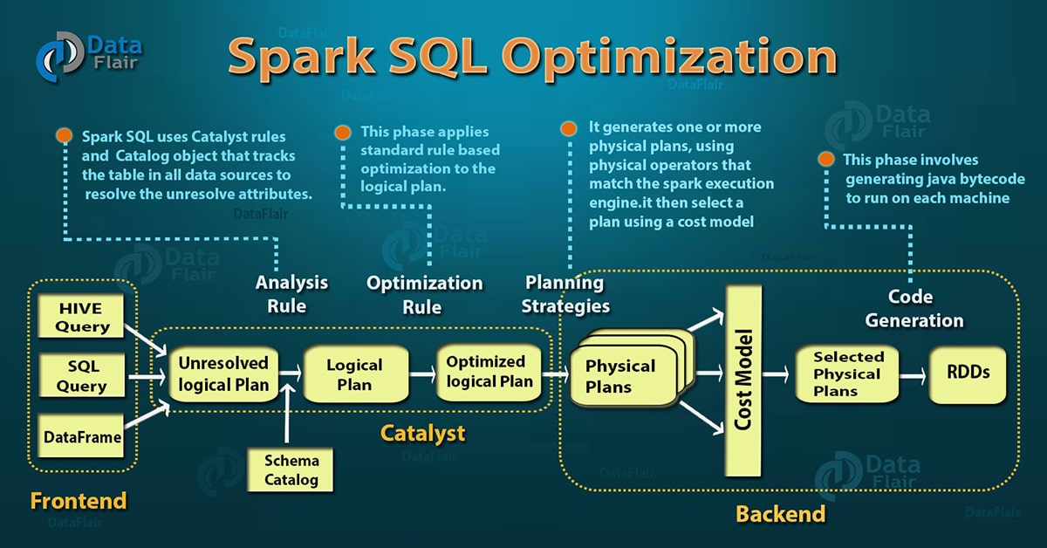

**1. Analysis:** Spark SQL Optimization starts from relation to be computed. It is computed either from abstract syntax tree (AST) returned by SQL parser or dataframe object created using API. Both may contain unresolved attribute references or relations. By unresolved attribute, it means we don’t know its type or have not matched it to an input table. Spark SQL make use of Catalyst rules and a Catalog object that track data in all data sources to resolve these attributes. It starts by creating an unresolved logical plan, and then apply the following steps:

Search relation BY NAME FROM CATALOG.

Map the name attribute, for example, col, to the input provided given operator’s children.

Determine which attributes match to the same value to give them unique ID.

Propagate and push type through expressions.

**2. Logical Optimization:** In this phase of Spark SQL optimization, the standard rule-based optimization is applied to the logical plan. It includes constant folding, predicate pushdown, projection pruning and other rules. It became extremely easy to add a rule for various situations.

**3. Physical Planning:** There are about 500 lines of code in the physical planning rules. In this phase, one or more physical plan is formed from the logical plan, using physical operator matches the Spark execution engine. And it selects the plan using the cost model. It uses Cost-based optimization only to select join algorithms. For small relation SQL uses broadcast join, the framework supports broader use of cost-based optimization. It can estimate the cost recursively for the whole tree using the rule.

Rule-based physical optimization, such as pipelining projections or filters into one Spark map Operation is also carried out by the physical planner. Apart from this, it can also push operations from the logical plan into data sources that support predicate or projection pushdown.

**4. Code Generation:** The final phase of Spark SQL optimization is code generation. It involves generating Java bytecode to run on each machine. Catalyst uses the special feature of Scala language, “Quasiquotes” to make code generation easier because it is very tough to build code generation engines. Quasiquotes lets the programmatic construction of abstract syntax trees (ASTs) in the Scala language, which can then be fed to the Scala compiler at runtime to generate bytecode. With the help of a catalyst, we can transform a tree representing an expression in SQL to an AST for Scala code to evaluate that expression, and then compile and run the generated code.

**Apache Spark vs Hadoop MapReduce**

|  |  |  |
| --- | --- | --- |
|  | **Apache Spark** | **Hadoop MapReduce** |
| **Introduction** | It is an open source big data framework. It provides faster and more general purpose data processing engine. Spark is basically designed for fast computation. It also covers a wide range of workloads for example batch, interactive, iterative and streaming. | It is also an open source framework for writing applications. It also processes structured and unstructured data that are stored in HDFS. Hadoop MapReduce is designed in a way to process a large volume of data on a cluster of commodity hardware. MapReduce can process data in batch mode. |
|  | **Apache Spark** | **Hadoop MapReduce** |
| **Speed** | Spark is lightning fast cluster computing tool. Apache Spark runs applications up to 100x faster in memory and 10x faster on disk than Hadoop. Because of reducing the number of read/write cycle to disk and storing intermediate data in-memory Spark makes it possible. | MapReduce reads and writes from disk, as a result, it slows down the processing speed. |
| **Difficulty** | Spark is easy to program as it has tons of high-level operators with RDD – Resilient Distributed Dataset. | In MapReduce, developers need to hand code each and every operation which makes it very difficult to work. |
| **Easy to Manage** | Spark is capable of performing batch, interactive and Machine Learning and Streaming all in the same cluster. As a result makes it a complete data analytics engine. Thus, no need to manage different component for each need. Installing Spark on a cluster will be enough to handle all the requirements. | As MapReduce only provides the batch engine. Hence, we are dependent on different engines. For example- Storm, Giraph, Impala, etc. for other requirements. So, it is very difficult to manage many components. |
| **Real-time analysis** | It can process real time data i.e. data coming from the real-time event streams at the rate of millions of events per second, e.g. Twitter data for instance or Facebook sharing/posting. Spark’s strength is the ability to process live streams efficiently. | MapReduce fails when it comes to real-time data processing as it was designed to perform batch processing on voluminous amounts of data. |
| **Latency** | Spark provides low-latency computing. | MapReduce is a high latency computing framework. |
| **Interactive mode** | Spark can process data interactively. | MapReduce doesn’t have an interactive mode. |
| **Streaming** | Spark can process real time data through Spark Streaming. | With MapReduce, you can only process data in batch mode. |
| **Ease of use** | Spark is easier to use. Since, its abstraction (RDD) enables a user to process data using high-level operators. It also provides rich APIs in Java, Scala, Python, and R. | MapReduce is complex. As a result, we need to handle low-level APIs to process the data, which requires lots of hand coding. |
| **Recovery** | RDDs allows recovery of partitions on failed nodes by re-computation of the DAG while also supporting a more similar recovery style to Hadoop by way of checkpointing, to reduce the dependencies of an RDDs. | MapReduce is naturally resilient to system faults or failures. So, it is a highly fault-tolerant system. |
| **Scheduler** | Due to in-memory computation spark acts its own flow scheduler. | MapReduce needs an external job scheduler for example, Oozie to schedule complex flows. |
| **Fault tolerance** | Spark is fault-tolerant. As a result, there is no need to restart the application from scratch in case of any failure. | Like Apache Spark, MapReduce is also fault-tolerant, so there is no need to restart the application from scratch in case of any failure. |
| **Security** | Spark is little less secure in comparison to MapReduce because it supports the only authentication through shared secret password authentication. | Apache Hadoop MapReduce is more secure because of Kerberos and it also supports Access Control Lists (ACLs) which are a traditional file permission model. |
| **Cost** | As spark requires a lot of RAM to run in-memory. Thus, increases the cluster, and also its cost. | MapReduce is a cheaper option available while comparing it in terms of cost. |
| **Language Developed** | Spark is developed in Scala. | Hadoop MapReduce is developed in Java. |
| **Category** | It is data analytics engine. Hence, it is a choice for Data Scientist. | It is basic data processing engine. |
| **Programming Language support** | Scala, Java, Python, R, SQL. | Primarily Java, other languages like C, C++, Ruby, Groovy, Perl, Python are also supported using Hadoop streaming. |
| **SQL support** | It enables the user to run SQL queries using Spark SQL. | It enables users to run SQL queries using Apache Hive. |
|  | **Apache Spark** | **Hadoop MapReduce** |
| **Scalability** | Spark is highly scalable. Thus, we can add n number of nodes in the cluster. Also a largest known Spark Cluster is of 8000 nodes. | MapReduce is also highly scalable we can keep adding n number of nodes in the cluster. Also, a largest known Hadoop cluster is of 14000 nodes. |
| **The line of code** | Apache Spark is developed in merely 20000 line of codes. | Hadoop 2.0 has 1,20,000 line of codes |
| **Machine Learning** | Spark has its own set of machine learning ie MLlib. | Hadoop requires machine learning tool for example Apache Mahout |
| **Caching** | Spark can cache data in memory for further iterations. As a result it enhances the system performance. | MapReduce cannot cache the data in memory for future requirements. So, the processing speed is not that high as that of Spark. |
| **Hardware Requirements** | Spark needs mid to high-level hardware. | MapReduce runs very well on commodity hardware. |
| **Community** | Spark is one of the most active project at Apache. Since, it has a very strong community. | MapReduce community has been shifted to Spark. |

**Apache Hive Vs Spark SQL**

|  |  |  |
| --- | --- | --- |
|  | **Apache Hive** | **SparkSQL** |
| **Introduction** | Apache Hive is built on top of Hadoop. Moreover, It is an open source data warehouse system. Also, helps for analyzing and querying large datasets stored in Hadoop files. At First, we have to write complex Map-Reduce jobs. But, using Hive, we just need to submit merely SQL queries. Users who are comfortable with SQL, Hive is mainly targeted towards them. | In Spark, we use Spark SQL for structured data processing. Moreover, We get more information of the structure of data by using SQL. Also, gives information on computations performed. One can achieve extra optimization in Apache Spark, with this extra information. Although, Interaction with Spark SQL is possible in several ways. Such as DataFrame and the Dataset API. |
| **Initial release** | Apache Hive was first released in 2012. | Apache Spark SQL was first released in 2014. |
| **Implementation language** | implement Apache Hive on Java language. | implement Spark SQL on Scala, Java, Python as well as R language. |
| **Developer** | Hive is originally developed by Facebook. But later donated to the Apache Software Foundation, which has maintained it since. | It is originally developed by Apache Software Foundation. |
| **APIs and other access methods** | Apache Hive supports JDBC, ODBC, and Thrift. | Spark SQL supports only JDBC and ODBC. |
| **Programming languages** | We can use several programming languages in Hive. For example C++, Java, PHP, and Python. | We can use several programming languages in Spark SQL. For example Java, Python, R, and Scala. This creates difference between SparkSQL and Hive. |
| **Partitioning methods** | It uses data sharding method for storing data on different nodes. | It uses spark core for storing data on different nodes. |
| **Replication methods** | There is a selectable replication factor for redundantly storing data on multiple nodes. | Basically, for redundantly storing data on multiple nodes, there is a no replication factor in Spark SQL. |
| **User concepts** | There are access rights for users, groups as well as roles. | There are no access rights for users. |
| **Usage** | Schema flexibility and evolution.  Also, can portion and bucket, tables in Apache Hive.  As JDBC/ODBC drivers are available in Hive, we can use it. | it is possible to read data from existing Hive installation.  We get the result as Dataset/DataFrame if we run Spark SQL with another programming language. |
| **Limitations** | It does not offer real-time queries and row level updates.  Also provides acceptable latency for interactive data browsing.  Hive does not support online transaction processing.  In Apache Hive, latency for queries is generally very high. | It does not support union type  Although, no provision of error for oversize of varchar type  It does not support transactional table  However, no support for Char type  It does not support time-stamp in Avro table. |

